EOI for trial collaboration with GenV

Please fill this form as completely as possible before submitting to solutionsgenv@mcri.edu.au. We aim to get back to you within a week to acknowledge your EOI, and to discuss next steps (eg ask for more information, make a time to talk).

You may wish to read GenV’s trials strategy at before filling it out.

- Lead contact’s name, email and phone number

- Name of trial PI

- Trial name. If registered, include trial registration number

- Aim of registry

- Rationale for study (~150 words)

- Brief description of trial: PICOT (~300 words)
- Population:
- Intervention:
- Comparison:
- Outcome:
- Time:

- Please list data (exposure / outcome / other) of interest with further details below. Please include any data you hope GenV may collect.
Data of interest (exposure / outcome / other - specify)  (please add extra rows as required) | Tool / Measure / Data source  (eg K10 questionnaire, ICU admission, pathology findings) | Timepoint (with year)  (eg T0 in June 2022, T1 in March 2023 – see table for Q12) | Participant (with age, if relevant)  (eg child aged 2 years, parent <50 years)
a.
b.
c.
d.
e.

- How would you like to collaborate with GenV?

- Please outline your proposed randomisation methods

- Does your trial involve Phase 1, 2 or 3 drugs and devices or invasive treatment?
Pick an option from this drop-down list
Enter additional comments.

- Please outline any potential risks to participants

- What is the expected sample size of the trial, assuming it includes only those born in the period of GenV recruitment (Oct 2021 to Sept 2023) or their parents? If the trial will be undertaken nationally or internationally, please include details of the expected sample size within Victoria.

- The proposed start date and duration of your trial

- How do the timepoints of your trial fit with the age of GenV participants across calendar years?
Please mark on the table below (eg T0, baseline; T1, 6 months; T3, 2 years). Green = GenV Vanguard, Orange = GenV Cohort.
Please note: Vanguard recruitment was undertaken from December 2020 to October 2021 and Cohort recruitment will occur from October 2021 to October 2023.

Age | Dates | 2021 |  | 2022 |  | 2023 |  | 2024 |  | 2025 |  | 2026 |  | 2027
0-1y | 10/2021-10/2024
1y-2y | 10/2022-10/2025
2y-3y | 10/2023-10/2026
3y-4y | 10/2024-10/2027

- At which sites or locations will the trial be delivered?

- Which of the collaboration models (on the graphic below) do you think might be most appropriate for this trial?
Pick an option from this drop-down list
Enter additional comments.
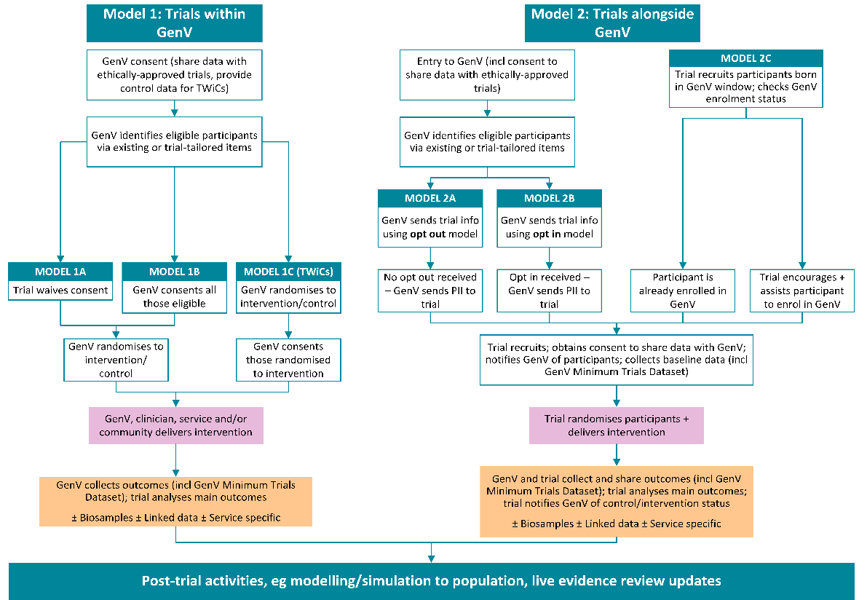

- Proposed trial design (eg RCT, stepped wedge, cluster, parallel group) and randomisation strategy (eg individual, cluster).

- Are funds available to support the trial?
Pick an option from this drop-down list
Enter additional comments.

- Please answer one of:
a. If you answered Yes – fully in question 18, please detail funding coverage, source and type.
b. If you answered Yes – partially in question 18, please detail which components are funded.
c. If you answered No – funding application currently in review in question 18, please provide further details of the application in review.
a.
b.
c.

- Have you obtained ethics approval for the study?
Pick an option from this drop-down list
Enter additional comments.

- Have you obtained sponsorship for the trial?
Pick an option from this drop-down list
Enter additional comments.

